**Infographic Title: Understanding Test-Driven Development (TDD)**

**Section 1: What is TDD?**

* **Definition**: Test-Driven Development (TDD) is a software development approach where tests are written before writing the code they are meant to validate.

**Section 2: TDD Cycle**

1. Write a Test

* Create a test for a new feature or functionality.
* Ensure the test covers the expected behavior.

1. Run the Test

* Execute the test to see it fail.
* This confirms that the feature isn’t already present.

1. Write Code

* Write the minimum amount of code required to pass the test.

1. Run All Tests

* Run all tests to ensure the new code doesn’t break existing functionality.
* Ensure the new test passes.

1. Refactor Code

* Improve the code structure while keeping all tests passing.
* Optimize and clean up the code.

1. Repeat

* Continue the cycle for new features or changes.

**Section 3: Benefits of TDD**

* Bug Reduction: Identifies issues early in the development process.
* Improved Code Quality: Encourages clean and maintainable code.
* Software Reliability: Increases confidence that the software behaves as expected.
* Documentation: Tests serve as a form of living documentation.
* Facilitates Refactoring: Safe to refactor with tests ensuring functionality remains intact.

**Section 4: TDD Best Practices**

* Small Iterations: Keep each cycle short and focused on a single aspect.
* Consistent Testing: Write tests for every new feature or change.
* Comprehensive Coverage: Ensure tests cover all possible scenarios.
* Refactor Regularly: Regularly clean up the code to maintain quality.
* Automated Testing: Use automated testing tools to streamline the process.

**Section 5: Visual Flow of TDD Process**

[Insert a circular diagram with arrows showing the flow between each step in the TDD cycle]

**Infographic Design Elements**

* Colors: Use a consistent color palette with contrasting colors for different sections.
* Icons: Use icons to represent each step in the TDD cycle (e.g., test, code, run, refactor).
* Flow Arrows: Use arrows to indicate the cyclical nature of the TDD process.
* Highlights: Use bold or different color text to emphasize key points like benefits and best practices.
* Examples: Small code snippets or examples to illustrate writing a test and then the code.

Now, I will create the infographic based on this structure.

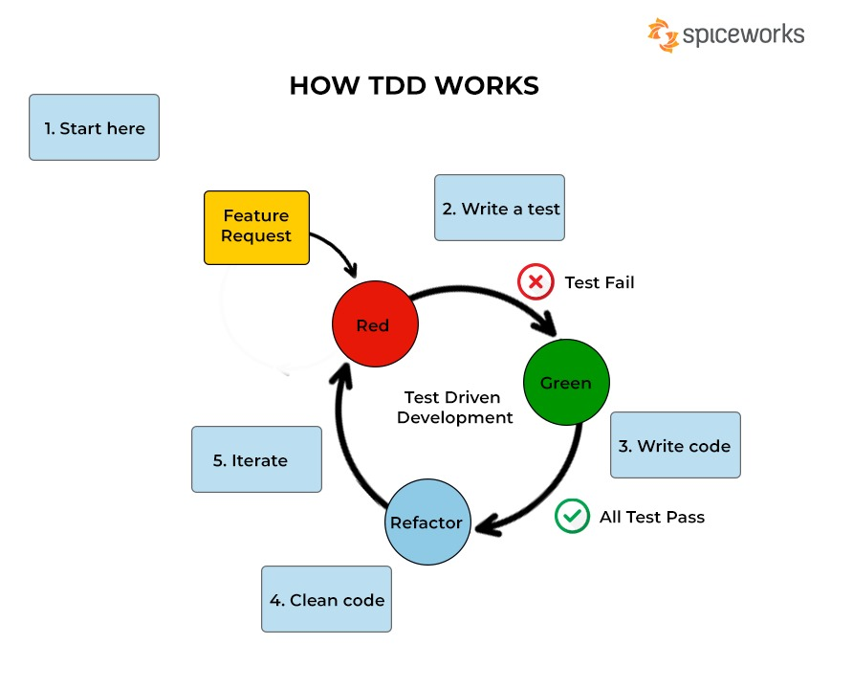

Here is an infographic illustrating the Test-Driven Development (TDD) process. It highlights the cycle of writing tests before code, the steps involved, and the benefits of TDD.

**Infographic Content**

Title: Understanding Test-Driven Development (TDD)

**TDD Cycle**

1. Write a Test
2. Run the Test
3. Write Code
4. Run All Tests
5. Refactor Code

These steps are shown in a circular flow to emphasize the iterative nature of TDD.

**Benefits of TDD**

* Bug Reduction
* Improved Code Quality
* Software Reliability
* Documentation
* Facilitates Refactoring